ChE 210 – Introduction to Thermodynamics –Fall 2019
Student Learning Outcome 1
Rubric for assessment problem on final exam (Problem #1)
Application of energy and entropy balances to a piston/cylinder device with water.

SLO 1  Performance Indicator (PI) | (1) Unsatisfactory | (2) Developing | (3) Satisfactory
1. Apply mathematical and scientific principles to formulate models and systems relevant to the subject | Able to successfully combines mathematical and/or scientific principles to formulate models and systems relevant to chemical engineering | Chooses a mathematical model or scientific principle that applies to an engineering problem, but has trouble in model development | Does not understand the connection between mathematical models and the system or process to be analyzed or designed
2. Solve engineering problems by using the concepts of algebra, calculus, differential equations and/or linear algebra | applies concepts of algebra, calculus, differential equations and/or linear algebra to solve chemical engineering problems | Shows nearly complete understanding of applications of calculus and/or linear algebra in problem-solving | Does not understand the application of algebra, calculus, differential equations and/or linear algebra in solving chemical engineering problems
4. Translates academic theory into engineering applications | Translates academic theory into engineering applications and accepts limitations of mathematical models of physical reality | Some gaps in understanding the application of theory to the problem and expects theory to predict reality | Does not appear to grasp the connection between theory and the problem

Averages:

Performance Indicators: (1) 2.33 (2) 1.90 (4) 2.19 Overall Average: 2.14

PI1 is clearly the weakest score. Many students struggled with basic mathematic skills for solving sets of algebraic equations. The course does give ample exercise of these skills in homework and during lecture. Students did better in developing material balances from first principles and analyzing unit operations correctly.

ChE 210 Final Exam Name:_________________________________
Wedgewood 9 December 2019

Open Book and Closed Notes
SPECIAL NOTE: Do all calculations in the exam booklet provided. To receive full credit, write your final answer in the space provide on this sheet. You must turn this sheet with your exam booklet.

- (50 points) Sucrose (C₁₂H₂₂O₁₁) can be converted to glucose and fructose (both C₆H₁₂O₆) according to the reaction
C₁₂H₂₂O₁₁ + H₂O → C₆H₁₂O₆ + C₆H₁₂O₆
Sucrose Water d-Glucose d-Fructose
The mixture of glucose and fructose is called inversion sugar (I). If we give sucrose the symbol S and water the symbol W, the reaction can be written simply as

S +W → 2 I.

The process is shown below where the reactor has a single-pass conversion of sucrose of 80%. The process is fed 100 kmol of 12.2 mol% S and the remainder W. The reactor effluent is fed into a splitter with a product stream and a recycle stream of identical composition. The recycle stream has a flow rate of n₄ = 20 kmol.
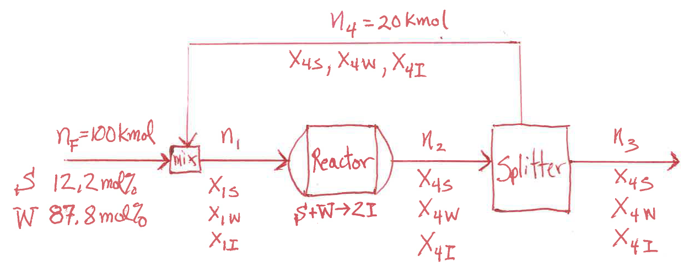

- Do a degree of freedom analysis following page 105 of the text and show that the problem is sufficiently specified. (5 pts.)

- Using balances on the total molar flow rates, calculate the molar flow rates of the reactor input, output, and the product stream. (15 pts.)

n₁ = ____________ kmol input, n₂ = ____________ kmol output, n₃ = ____________ kmol product

(c) Using balances on species, write six more independent equations to calculate the mole fractions of the input and output stream for the reactor. These equations should be linear in the unknowns. (30 pts.)

x_{1S =} ________________ , x_{1W =} ________________ , x_{1I =} ________________

x_{4S =} ________________ , x_{4W =} ________________ , x_{4I =} ________________
